Streamlining Ticket Assignment for Efficient Support Operations

Team Id : NM2025TMID17664

Team Member : 5

Team Leader :  MOHAMMED ASHIKA K

Team member 1 : KAVIYA SRI L

Team member 2 : MALATHI L

Team member 3 : MOHANA S

Team member 4 : MOHANA SAKTHI L

Problem Statement :

The goal of this project is to create an automated system that sends support tickets to the right teams at ABC Corporation.

Purpose :

* + Solve customer issues faster
  + Improve customer satisfaction
  + Use support team’s time and resources more efficiently

Objective :

The goal of this project is to set up an automated system that sends support tickets to the right teams at ABC Corporation. The aims are to:

* Make operations more efficient
* Speed up issue resolution
* Make customers happier
* Use the support team's resources better

Skills :

Here’s that in simpler English:

* **TensorFlow**: Used to create and train machine learning models that help sort tickets and predict which team should handle them.
* **Spring**: Used to build and manage the backend system that automates ticket routing and connects everything together.

TASK INITIATION

Milestone 1 : User

Activity 1 : Create User

1. Open service now.
2. Click on All  >> search for users
3. Select Users under system security
4. Click on new
5. Fill the following details to create a new user

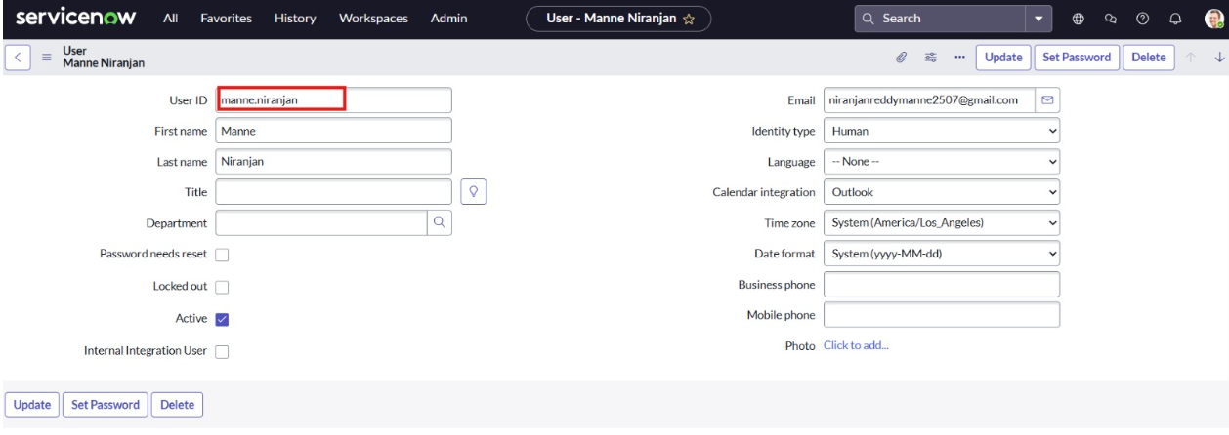

6.Click on submit  
  
Create one more user:

7.Create another user with the following details

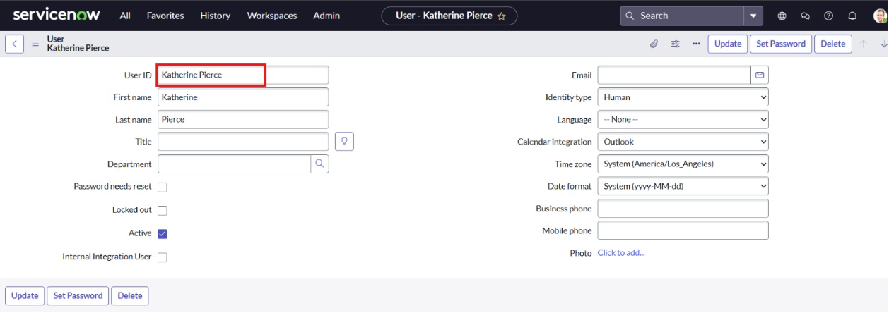

8.Click on submit

Milestone 2 : Groups

Activity 1 : Create Groups

1. Open service now.
2. Click on All  >> search for groups
3. Select groups under system security
4. Click on new
5. Fill the following details to create a new group

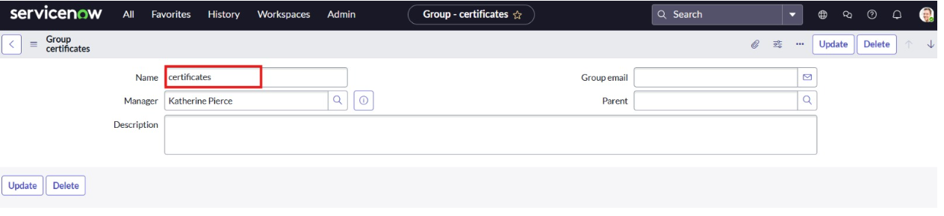

1. Click on submit

Create one more group:

1. Create another group with the following detail

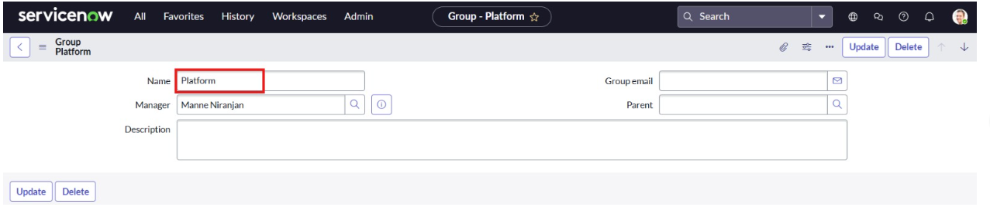

1. Click on submit

Milestone 3 : Roles

Activity 1 : Create Roles

1. Open service now.
2. Click on All  >> search for roles
3. Select roles under system security
4. Click on new
5. Fill the following details to create a new role

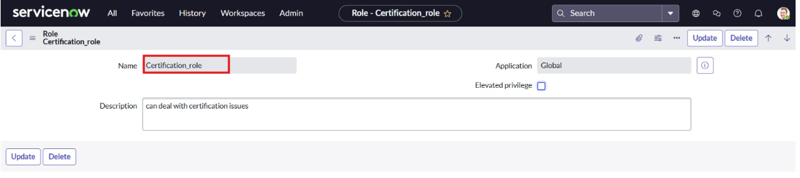

1. Click on submit

Create one more role:

Create another role with the following details

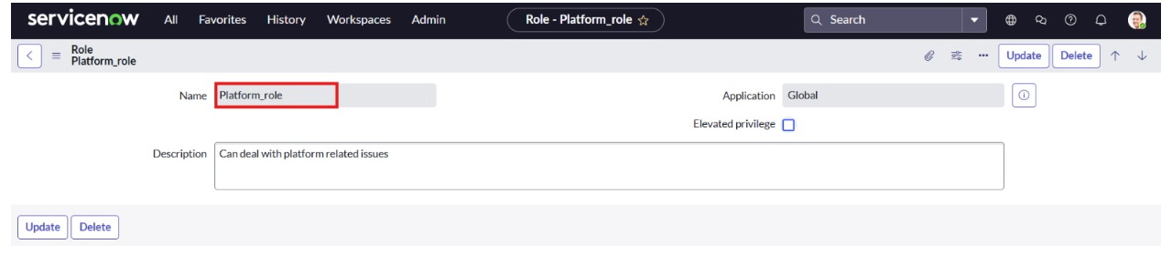

Click on submit

Milestone 4 : Tables

Activity 1 : Create Table

1. Open service now.
2. Click on All  >> search for tables
3. Select tables under system definition
4. Click on new
5. Fill the following details to create a new table  
   Label : Operations related  
   Check the boxes Create module & Create mobile module
6. Under new menu name : Operations related
7. Under table columns give the columns

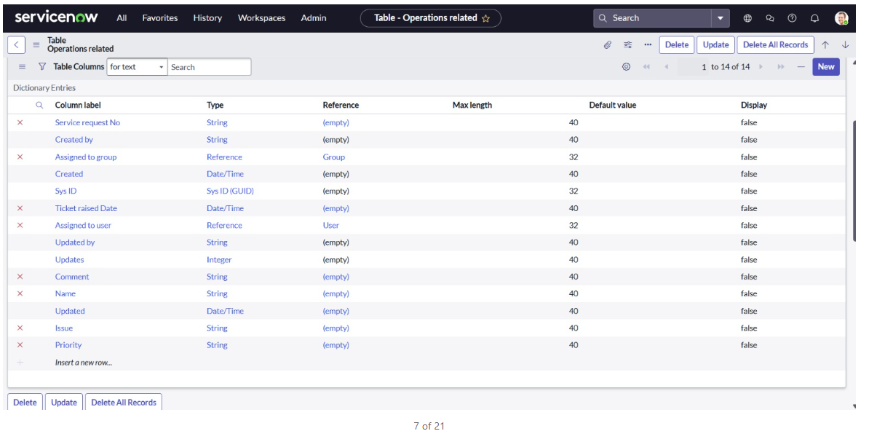

1. Click on submit

Create choices for the issue filed by using form design  
Choices are

* 1. unable to login to platform
  2. 404 error
  3. regarding certificates
  4. regarding user expired

Milestone 5 : Assign users to groups

Activity 1 : Assign roles & users to certificate group

1. Open service now.
2. Click on All  >> search for tables
3. Select tables under system definition
4. Select the certificates group
5. Under group members
6. Click on edit
7. Select Katherine Pierce and save
8. Click on roles
9. Select Certification_role and save

Activity 2 : Assign roles & users to platform group

1. Open service now.
2. Click on All  >> search for tables
3. Select tables under system definition
4. Select the platform group
5. Under group members
6. Click on edit
7. Select Manne Niranjan and save
8. Click on roles
9. Select Platform_role and save

Milestone 6 : Assign roles to table

Activity 1 : Assign roles to table

1. Open service now.
2. Click on All  >> search for tables
3. Select operations related table
4. Click on the Application Access
5. Click on u_operations_related read operation
6. Click on the profile on top right side
7. Click on elevate role
8. Click on security admin and click on update
9. Under Requires role
10. Double click on insert a new row
11. Give platform role
12. And add certificate role
13. Click on update

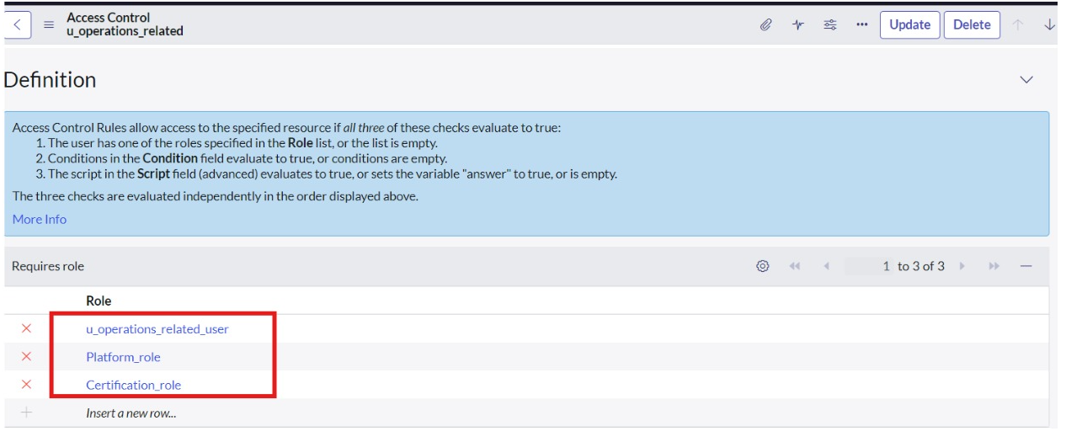

1. Click on u_operations_related write operation
2. Under Requires role
3. Double click on insert a new row
4. Give platform role
5. And add certificate role

Milestone 7 : Create ACL

Activity 1 : Create ACL

1. Open service now.
2. Click on All  >> search for ACL
3. Select Access Control(ACL) under system security
4. Click on new
5. Fill the following details to create a new ACL

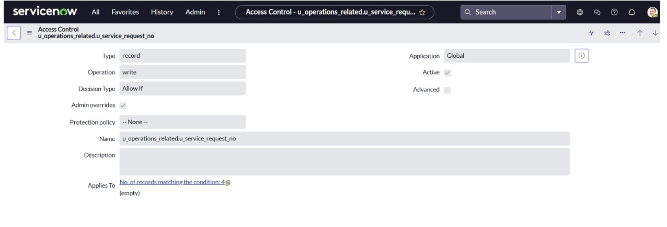

1. Scroll down under requires role
2. Double click on insert a new row
3. Give admin role
4. Click on submit
5. Similarly create 4 acl for the following fields

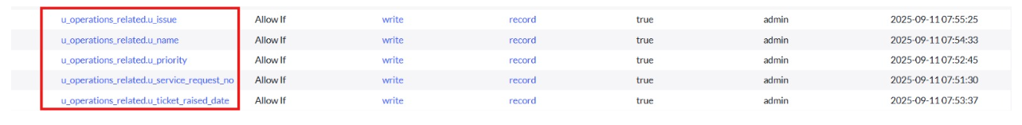

Milestone 8 : Flow

Activity 1 : Create a Flow to Assign operations ticket to group

1. Open service now.
2. Click on All  >> search for Flow Designer
3. Click on Flow Designer under Process Automation.
4. After opening Flow Designer Click on new and select Flow.
5. Under Flow properties Give Flow Name as “ Regarding Certificate”.
6. Application should be Global.
7. Select Run user as “ System user ” from that choice.
8. Click on Submit.

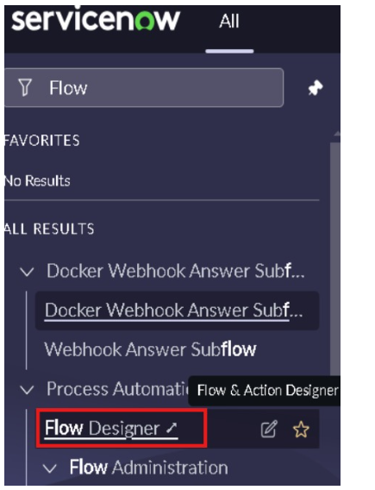

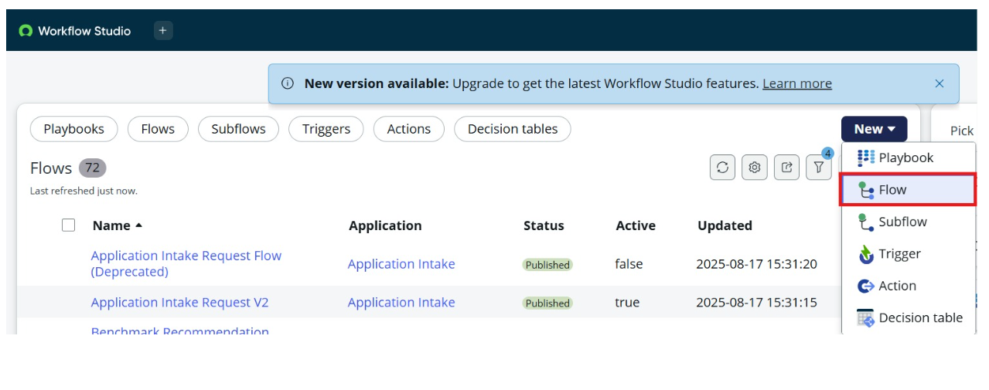

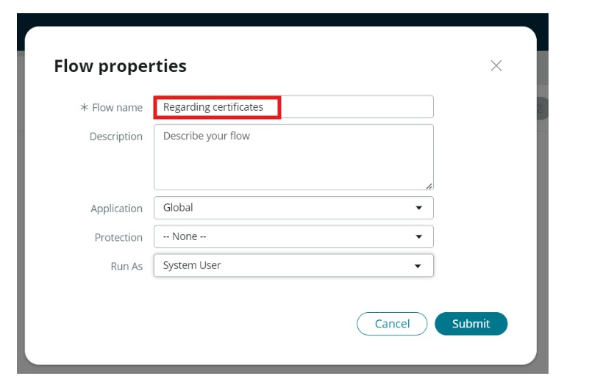

1. Click on Add a trigger
2. Select the trigger in that Search for “create or update a record”  and select that.
3. Give the table name as “ Operations related ”.
4. Give the Condition as  
   Field : issue

Operator : is

Value : Regrading Certificates

1. After that click on Done.

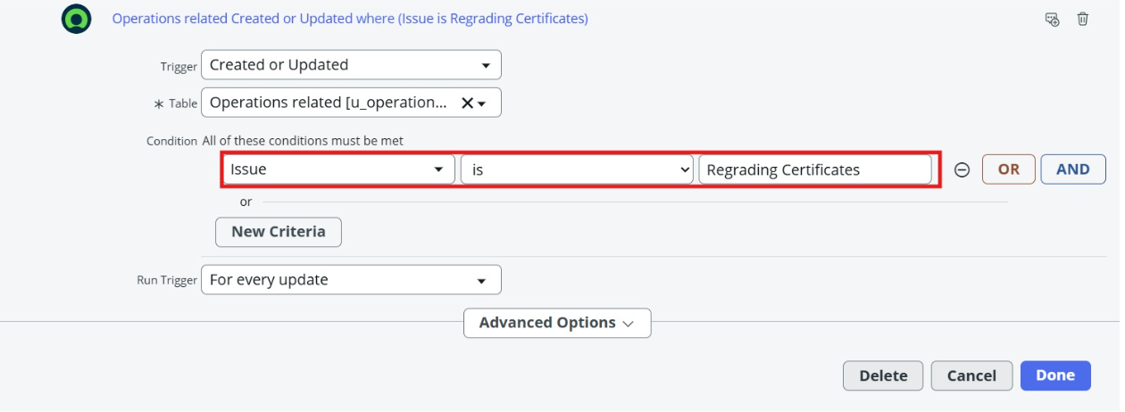

1. Now under Actions.
2. Click on Add an action.
3. Select action in that search for “ Update Record ”.
4. In Record field drag the fields from the data navigation from left side
5. Table will be auto assigned after that
6. Give the field as “ Assigned to group ”
7. Give value as “ Certificates ”
8. Click on Done.
9. Click on Save to save the Flow.
10. Click on Activate

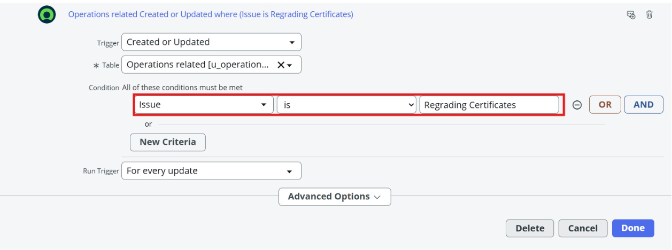

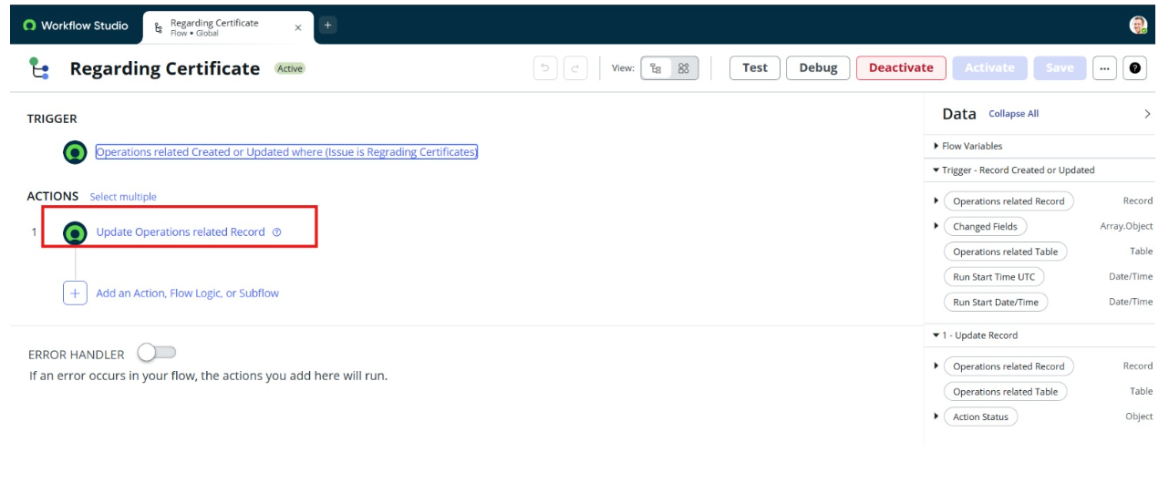

Activity 2 : Create a Flow to Assign operations ticket to Platform group

1. Open service now.
2. Click on All  >> search for Flow Designer
3. Click on Flow Designer under Process Automation.
4. After opening Flow Designer Click on new and select Flow.
5. Under Flow properties Give Flow Name as “ Regarding Platform ”.
6. Application should be Global.
7. Select Run user as “ System user ” from that choice.
8. Click on Submit.
9. Click on Add a trigger
10. Select the trigger in that Search for “create or update a record”  and select that.
11. Give the table name as “ Operations related ”.
12. Give the Condition as  
    Field : issue

Operator : is

Value : Unable to login to platform

1. Click on New Criteria

Field : issue

Operator : is

Value : 404 Error

1. Click on New Criteria

Field : issue

Operator : is

Value : Regrading User expired

1. After that click on Done.
2. Now under Actions.
3. Click on Add an action.
4. Select action in that search for “ Update Record ”.
5. In Record field drag the fields from the data navigation from left side
6. Table will be auto assigned after that
7. Give the field as “ Assigned to group ”.
8. Give value as “ Platform ”.
9. Click on Done.
10. Click on Save to save the Flow.
11. Click on Activate.

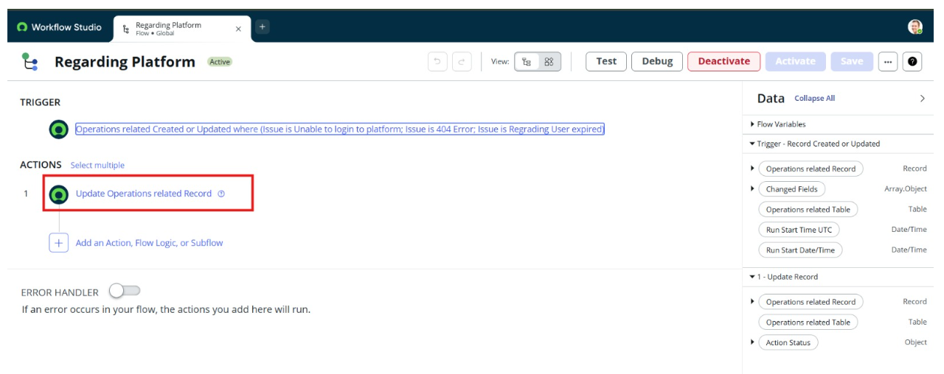

### Conclusion :

The automated ticket routing system at ABC Corporation has worked really well. By using ServiceNow, we've made it easier to assign support tickets to the right teams. This has helped solve the problems caused by manual routing and ensures that issues are fixed faster.